Complex Queries:

Complex queries have 3 or more tables joined, a custom scalar function and use built-in SQL functions and group by summarization.

**Premise 01:** How many vacation days have been taken by each department?

**Detailed explanation of the problem:** Return all Departments and the calculated amount of vacation days each has taken.

**Query**:



**Sample Output:**

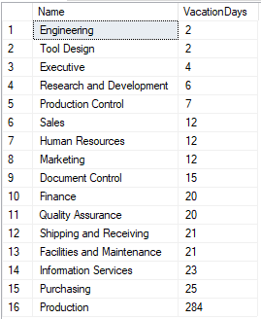

**Premise 02:** Provide the Email Addresses for those who have taken the most vacation days.

**Detailed explanation of the problem:** Return the first name, last name, and e-mail address of the top 10 employees with the most vacation days.

**Query**: 

**Sample Output:**

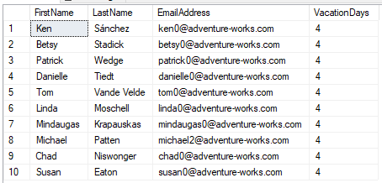

**Premise 03:** Which states/regions have the most orders shipping within 2 weeks?

**Detailed explanation of the problem:** Return all the States and Countries, and the amount of Orders that are shipping in rates less than 2 weeks.

**Query**: 

**Sample Output:**

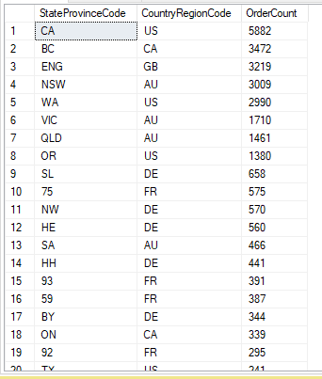

**Premise 04:** Which sales country has taken the most vacation days?

**Detailed explanation of the problem:** Return the top country with the most vacation days taken.

**Query**: 

**Sample Output:**



**Premise 05:** What is the average amount of sales per month for each store?

**Detailed explanation of the problem:** Return all store names, and the calculated average of their sales per month.

**Query**:**Sample Output:**

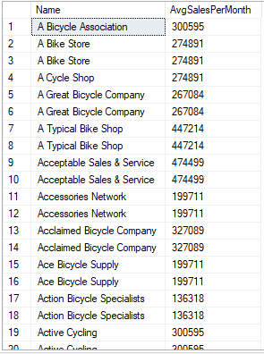

**Premise 06:** How many employees were hired in January for each department?

**Detailed explanation of the problem:** Return all Departments and the count of employees hired in January.

**Query**: 

**Sample Output:**

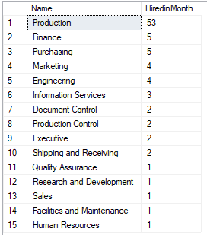

**Premise 07:** Provide the E-Mail Addresses for employees hired in June**.**

**Detailed explanation of the problem:** Return all Email Addresses for Employees hired in June.

**Query**: 

**Sample Output:**

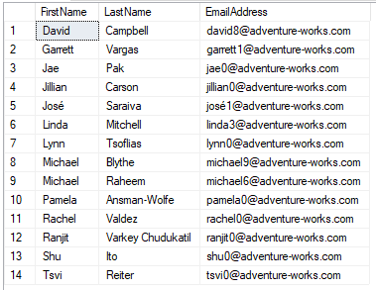

**Premise 08:** Provide the same information as above for employees hired on the same month as their birthday.

**Detailed explanation of the problem:** Return all Email Addresses for employees hired on their birth month.

**Query**: 

**Sample Output:**

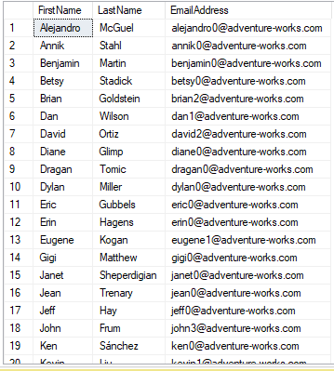

**Premise 09:** Who was hired in 2009, and what are their phone numbers?

**Detailed explanation of the problem:** Return the Last Name and Phone Numbers associated with the employees hired in 2009.

**Query**: 

**Sample Output:**

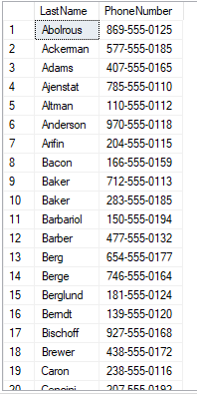

**Premise 10:** Provide the average pay rates of employees hired in 2010 for each department?

**Detailed explanation of the problem:** Return all Departments and the average pay rate for each one. Make sure it is for 2010 employees only.

**Query**: 

**Sample Output:**

